Financial Report

Robert Manni

10/9/2021

# Scope

This report is to elucidate from the data the trends between different industries and the relationship between growth, profit and overall revenue in these different industries from a dataset of 500 companies.

## Deliverables:

1. A grpah displaying revenue, expenses and profit by industry.
2. A graphical representation of the relationship between expenses and revenue by industry.
3. A graphical represenation of growth by industry.

# Results

## Overview:

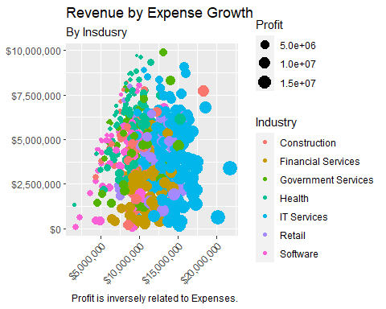

## Relationship of Revenue Growth to Expenses by Industry

## `geom_smooth()` using method = 'loess' and formula 'y ~ x'

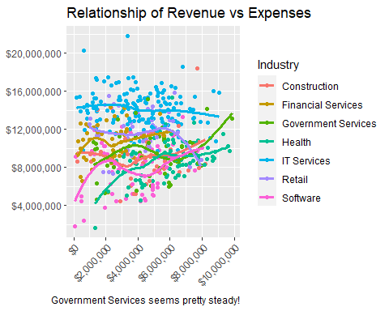

## Overall Growth by Industry

